International Workshop

**Laws of nature, rules of society, and freedom. Bergson today**

Faculty of Arts

Charles University, Prague

8-9 January 2024

Venue:

Institute of Philosophy

AKC, Husova 4a, 110 00

Prague 1, Czech republic

Monday, January 8:

10:00 - 10:50

Mark Sinclair(Queen's University Belfast): **Retroactive freedom**

11:10 - 12:00

Joël Dolbeault (Charles-de-Gaulle University, Lille, France): **Incompatibilism without Alternative Possibilities: Bergson in the Debate on Free Will**

14:00 - 14:50

Pavel Arazim (Charles University, Prague; Czech Academy of Sciences, Prague): **Rules in motion: rule-following with Bergson and Wittgenstein**

15:10 - 16:00

Yoann Malinge (Université catholique de Louvain, Belgium): **Being the cause of one's actions. Examining the free action in Bergson's philosophy**

16:30 - 18:00: Book Session

Matyáš Moravec (University of Saint Andrews, United Kingdom): **Henri Bergson and the philosophy of religion. God, Freedom, and Duration(Routledge 2023)** Commentators: Yasushi Hirai and Mark Sinclair.

Tuesday, January 9:

10:00 - 10:50

Jakub Čapek (Charles University, Prague): **Freedom as Hesitation. Henri Bergson in the Light of the Phenomenological Criticism**

11:10 - 12:00

Yasushi Hirai (Keio University, Japan): **How Freedom Originates from Closure: Through the Bergsonian Lens of Tense, Aspect, and Modality**

12:20 - 13:10

Paola Marrati (Johns Hopkins University, USA): **Bergson and the Fragility of Democratic Societies**

Funded by

**The Ian Ramsey Centre for Science and Religion**, **Oxford University**

and

**Charles University, Faculty of Arts**

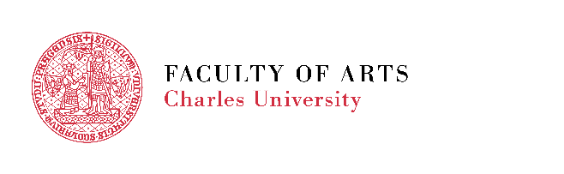Obrazec John Templeton Foundation Logo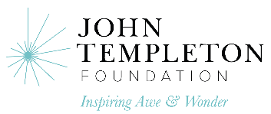 Obrazec John Templeton Foundation Logo

Obrazec John Templeton Foundation Logo

